Past Participle as an Object Complement

✅ What Is a Past Participle as an Object Complement?
# Source: AI Source: Provided by: [Data Path: Persons Table -> ID Column: 1, Name_En Column: Motasem Essam] -> From: [ChatGPT] on [8/4/2025]
A past participle (usually ending in -ed, -en, or irregular forms) can serve as an object complement when it follows a direct object and describes the state or condition the object ends up in as a result of the action.

🔸 Key Features:
# Source: AI Source: Provided by: [Data Path: Persons Table -> ID Column: 1, Name_En Column: Motasem Essam] -> From: [ChatGPT] on [8/4/2025]
- Follows a direct object
- Uses the past participle form of a verb (e.g., broken, painted, done)
- Indicates a resulting state or passive action
- Common with verbs like:
get, have, make, keep, leave, find, consider

🔸 Examples of Past Participle Object Complements:
# Source: AI Source: Provided by: [Data Path: Persons Table -> ID Column: 1, Name_En Column: Motasem Essam] -> From: [ChatGPT] on [8/4/2025]
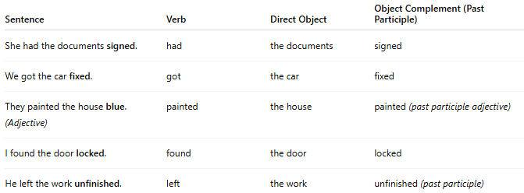
Sentence | Verb | Direct Object | Object Complement (Past Participle)
She had the documents signed. | had | the documents | signed
We got the car fixed. | got | the car | fixed
They painted the house blue. (Adjective) | painted | the house | painted (past participle adjective)
I found the door locked. | found | the door | locked
He left the work unfinished. | left | the work | unfinished (past participle)

🔸 How to Identify:
# Source: AI Source: Provided by: [Data Path: Persons Table -> ID Column: 1, Name_En Column: Motasem Essam] -> From: [ChatGPT] on [8/4/2025]
Ask:
- “What did she have the documents (done)?” → Signed
- “What was the condition of the door when he found it?” → Locked
If the complement describes a result or passive state of the direct object using a past participle, it is a past participle object complement.

